One Point Perspective Tasks
Warm-Up
- Draw your name in one-point perspective but going in different directions.
- Add color with colored pencils and apply appropriate tones
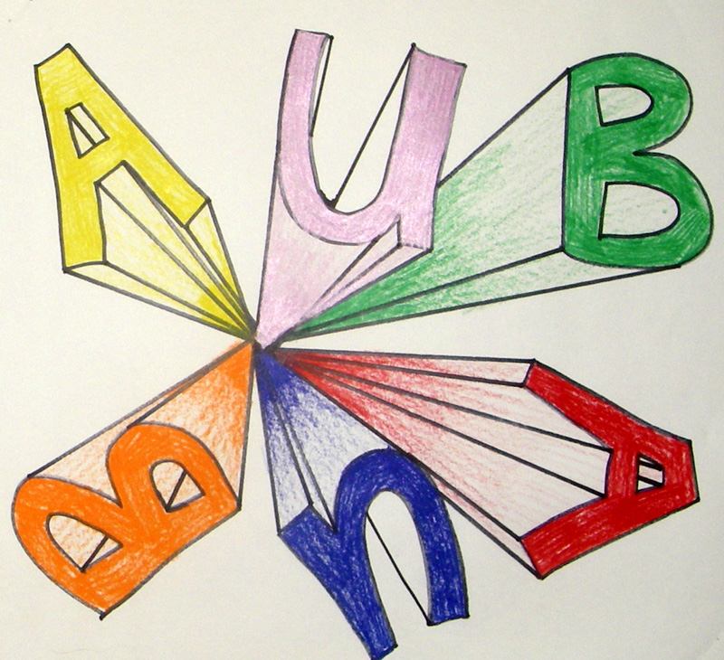
Main Task
Design your own comic book front cover with one-point perspective title and a new superhero of your own invention!

Reflection
Where else would you use one-point perspective?
How does it help you draw objects?
Thinking back to the ‘precious’ project, what artwork would you make and how would you use one-point perspective?

Next Lesson
Two-Point perspective

