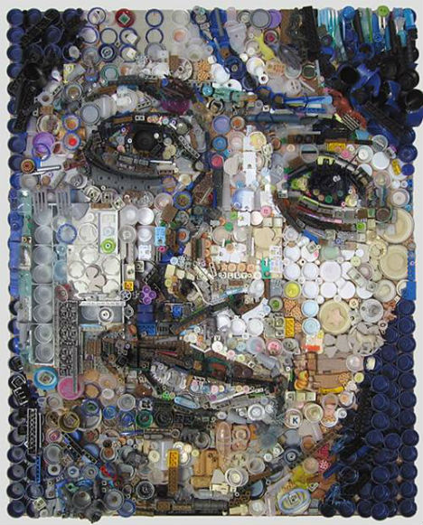

An artist is someone who can see a possibility in anything, whether that be in paint or clay or whether that be with something quite unusual; bottle baps, old computer parts, toys, window frames... What can you use to make art?

UNIT 3
ART TROUVE/ FOUND ART
Investigation Work Book = 40%
Tasks

Research Criteria

Culture and Context
Analyse and compare, art from different cultures and times, carefully consider the function and significance.
Technical Process
Demonstrate the development
of effective skills, techniques
and processes when making
and analysing images and
artifacts.
Investigation
Demonstrate coherent and
focused investigative strategies into visual qualities, ideas and their contexts. Use a range of approaches towards their study, and make connections between them.
Depth and Breath
Demonstrate depth and
breadth through a mostly
successful development of ideas and explain connections
between the your work and that of artists.

Give a presentation to the class about ‘art trouve’. Give it’s history and context. Find two artists, from different cultures, analyze their work, explain how their culture and background may have affected their work and comparer and contrast them.
Begin to collect your materials and try putting them together. Experiment with a range of different construction techniques and display ideas.
Write down and discuss ideas you may have about a found art project. Use ’Pintrest’ to get some ideas. Go to an art gallery to see what you can find. Study other IB students work from old sketchbook and exhibitions.

Review your work before you start a studio work, is your media appropriate to your meaning? How could you do it better? During a group discussion refine your ideas and generate new meaning giving your more depth. Have a first idea and a second idea page afterward
Presentation Criteria – (Considered on every page)
Vocabulary
Demonstrate careful and accurate use of the specialist vocabulary of visual arts.

Acknowledge Sources
Use an appropriate range of sources and acknowledge them properly.

Presentation
Presents the work effectively and creatively and demonstrates some good critical observation and reflection.

Integration
Present work effectively and creatively, demonstrating good critical observation and reflection.

Studio Work = 60%
Final Task
Use Found Objects to generate one or more three-dimensional Work. Must be thought provoking!

Final Piece Criteria

Understanding
Exhibit clear understanding
of the ideas and techniques that underpin artistic expression

Relevance
Consistently demonstrate the
production of personally relevant artworks that show exploration of ideas reflecting
cultural and historical
awareness and artistic qualities.

Development
Show thoughtful development
of ideas and strategies for
expression.

Sensitivity
Display sensitivity to materials
and their use. Review,
modify and refine your work as it progresses, resolving your ideas and media.

Technique
Display excellent technical
Competence.

Confidence
Demonstrate confidence and
inventiveness.

Independence
Shows an informed, reflective
judgment that challenges and
extends personal boundaries.

Limitations
Can be sculpture or installation. Can hang or stand. Must be at least 10 hours work.

Things to Consider
Have I put in appropriate time and energy?

Have I truly explored my ideas to create interesting, adventurous studio work (or have I just settled for the obvious)? Have I used any unusual or unexpected combinations of ideas or materials in my studio work?

How are the ideas in my studio work connected with my own life and cultural background? Have I created strong, powerful pieces of art work which really mean something to me?”

Are the ideas behind my studio work well suited to the techniques and media that I have chosen to use? What is the personal, cultural or visual meaning/purpose of my studio work?

How effectively have I designed the appearance of my studio work? Have I used visual language well? (line, composition, form, tone, colour, texture etc) Which visual or artistic problems have I encountered and have I solved them well?

Am I using my chosen media with high levels of skill? What visual effects do I want to create? How effective is the medium I have chosen at creating these effects? Would it be better to choose a different medium?”

Can I distinguish between my good and not-so-good art works, explaining how each piece has contributed to my improvement?

Appropriate Resources
Joseph Kosuth
John Lefelhocz
Sarah Lucas
David Mach
Michael Craig-Martin
Rodney McMillian
Louise Nevelson
Nam June Paik
Niki de Saint Phalle
Pablo Picasso
Robert Rauschenberg
Man Ray
Joe Rush
Leo Sewell
Daniel Spoerri
Kurt Schwitters
Michelle Stitzlein
Tomoko Takahashi
Wolf Vostell

Artists:
Arman
Joseph Beuys
Guillaume Bijl
George Brecht
Jake and Dinos Chapman
Greg Colson
Joseph Cornell
Tony Cragg
Salvador Dalí
Jack Daws
Marina DeBris
Jim Dine
Mark Divo
Marcel Duchamp
Tracey Emin
Tom Friedman
Jim Gary
Genco Gulan
Damien Hirst
Lonnie Holley
Jasper Johns

Websites:
http://www.treehugger.com/lawn-garden/striking-recycled-art-sculptures-double-habitat-solitary-bees.html
http://webecoist.momtastic.com/2012/01/16/found-object-art-13-sculptures-made-of-reclaimed-items/
www.tedtalks.com
Www.pintrest.com
http://www.moma.org/collection/details.php?theme_id=10135
http://artsy.net/gene/use-of-found-objects

Bangkok:
https://www.facebook.com/pages/Ashop-Recycle-Cans-Art/471450566276897
Bangkok’s Khlong Bang Luang artist village
http://thailand.prd.go.th/thailand_illustrated/content.php?s_id=289
http://www.dailymail.co.uk/news/article-2019609/Bangkok-artist-makes-drivable-sci-fi-sculpture-spare-parts.html
http://www.nationmultimedia.com/life/A-CITY-REBORN-IN-ART-30194351.html
http://theartelephant.com/travels/bangkok-art-installation-made-of-recycled-scooter-parts/

Books:
Duchamp – by Jannis Mink
Found Object Art – by Dorothy Spencer
Altered Curiosities: Assemblage Techniques and Projects - by Jayne Ann Waynne

Exhibitions:
http://www.artonlinev64.com/messy-brain-recycled-materials/

