**Investigation Work Book = 40%**

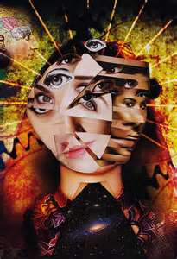

How do artists begin to understand something? How do they approach study? What is their point of view?

Is it the same way a mechanic understands the way a machines works? If a creative person takes something apart, how will they put it back together?

UNIT 2 DEFRAGMENTATION

Create research page about how artists documented 3D objects in a 2D form. Compare and Contrast cubist artists Braque and Picasso and then study the more recent photomontage artist, David Hockney

**TASKS**

Practice similar techniques to your artists in both paint and photomontage, refining technical skills with both a paint brush and a camera. Be sure to analyse your techniques and compare the result with you artists.

Complete a cultural or personal study, explaining how certain objects are symbolic of certain things and relate it to your project. Apply this to your still life objects within a cubist style.

Analyse and reflect upon your experiments deciding which are your most successful works. Combine these together to make bran new art works

Choose your most successful technique and develop a series of ideas and processes. Record your thoughts and opinions as you go and consider your final studio work.

**Studio Work = 60%**

**Presentation Criteria – (Considered on every page)**

**Vocabulary**

Demonstrate careful and accurate use of the specialist vocabulary of visual arts.

**Acknowledge Sources**

Use an appropriate range of sources and acknowledge them properly.

**Presentation**

Presents the work effectively and creatively and demonstrates some good critical observation and reflection.

**Integration**

Present work effectively and creatively, demonstrating good critical observation and reflection.

**Research Criteria**

**Culture and Context**

Analyse and compare, art from different cultures and times, carefully consider the function and significance.

**Technical Process**

Demonstrate the development

of effective skills, techniques

and processes when making

and analysing images and

artifacts.

**Investigation**

Demonstrate coherent and

focused investigative strategies into visual qualities, ideas and their contexts. Use a range of approaches towards their study, and make connections between them.

**Depth and Breath**

Demonstrate depth and

breadth through a mostly

successful development of ideas and explain connections

between the your work and that of artists.

**Final Piece Criteria**

**Understanding**

Exhibit clear understanding

of the ideas and techniques that underpin artistic expression

**Relevance**

Consistently demonstrate the

production of personally relevant artworks that show exploration of ideas reflecting

cultural and historical

awareness and artistic qualities.

**Development**

Show thoughtful development

of ideas and strategies for

expression.

**Sensitivity**

Display sensitivity to materials

and their use. Review,

modify and refine your work as it progresses, resolving your ideas and media.

**Technique**

Display excellent technical

Competence.

**Confidence**

Demonstrate confidence and

inventiveness.

**Independence**

Shows an informed, reflective

judgment that challenges and

extends personal boundaries.

**AppropriateResources**

**Final Task**

An Artwork in either 2D or 3D, turning the real – surreal, creating abstract form from still life objects that are personally or cultural relevant to you.

**Things to Consider**

Have I put in appropriate time and energy?

Have I truly explored my ideas to create interesting, adventurous studio work (or have I just settled for the obvious)? Have I used any unusual or unexpected combinations of ideas or materials in my studio work?

How are the ideas in my studio work connected with my own life and cultural background? Have I created strong, powerful pieces of art work which *really mean something* to me?”

Are the ideas behind my studio work well suited to the techniques and media that I have chosen to use? What is the personal, cultural or visual meaning/purpose of my studio work?

How effectively have I designed the appearance of my studio work? Have I used visual language well? (line, composition, form, tone, colour, texture etc) Which visual or artistic problems have I encountered and have I solved them well?

Am I using my chosen media with high levels of skill? What visual effects do I want to create? How effective is the medium I have chosen at creating these effects? Would it be better to choose a different medium?”

Can I distinguish between my good and not-so-good art works, explaining how each piece has contributed to my improvement?

**Limitations**

Studio works should be bigger than. They must include paint and photographs. Other media included is acceptable but should be experimented with first.

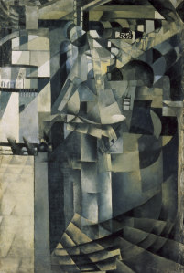

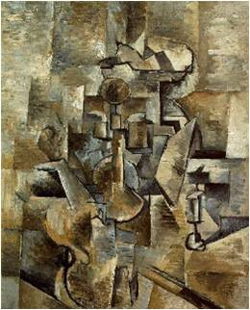

**Deadline = Dec16th**

**Minimum Pages = 15 + 1 Studio Work**

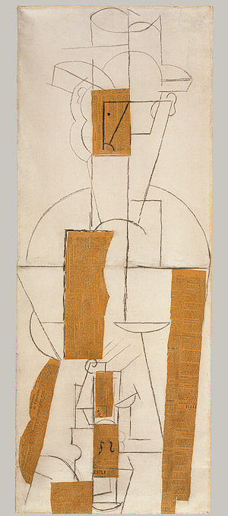

Jean Metzinger

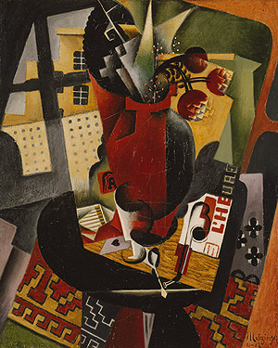

Diego Rivera

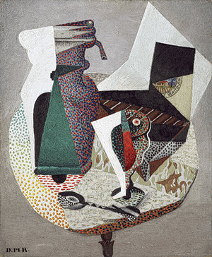

Juan Gris

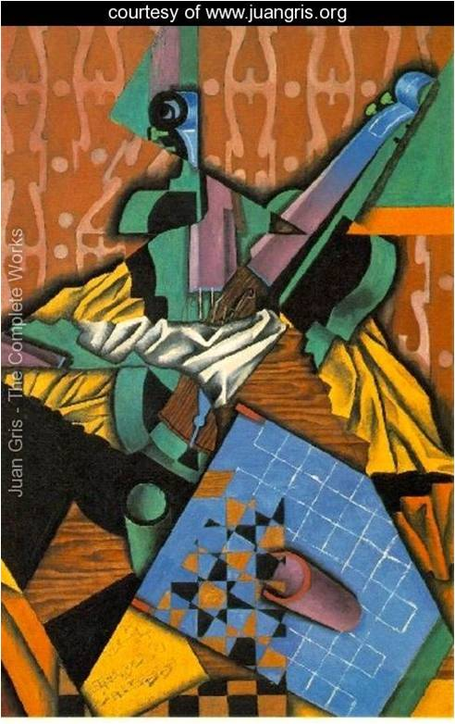

Kasimir Malevich

**Artists**

**David Hockney**

**George Braque**

**Juan Gris**

**Kasimir Malevich**

**Diego Rivera**

**Pablo Picasso**

**Roger De La Fresnaye**

**Tom Napper**  **Fernand Leger**

**Jean Metzinger**

**Umberto Boccioni**

**Harold Oljarz**

**Jeremy Wolff**

**Tom Napper**

<http://www.metmuseum.org/toah/hd/cube/hd_cube.htm>

**[http://www.artyfactory.com/art_appreciation/art_movements/](http://www.artyfactory.com/art_appreciation/art_movements/  cubism.htm)**

**[cubism.htm](http://www.artyfactory.com/art_appreciation/art_movements/  cubism.htm)**

[**http://www.ibiblio.org/wm/paint/auth/hockney/**](http://www.ibiblio.org/wm/paint/auth/hockney/)

[**http://web.archive.org/web/20071119143000/http://www.mcs. csuhayward.edu/~malek/Hockney.html**](http://web.archive.org/web/20071119143000/http://www.mcs.%20csuhayward.edu/~malek/Hockney.html)

[**http://www.olejarz.com/art/bigpicture/index.html**](http://www.olejarz.com/art/bigpicture/index.html)

*http://www.bbc.co.uk/dna/h2g2/A449921*

*http://nga.gov.au/Hockney/index.cfm*

[*http://blakeandrews.blogspot.com/2008/01/hockney-on-photography*](http://blakeandrews.blogspot.com/2008/01/hockney-on-photography)

*http://findarticles.com/p/articles/mi_m1310/is_/ai_6354424 article*

*http://www.guardian.co.uk/media/2004/mar/04/pressandpublishing.arts*

*http://www.hockneypictures.com/home.php*

*http://www.artinthepicture.com/artists/David_Hockney/biography.html*

*http://www.guardian.co.uk/artanddesign/2003/jan/06/art.artsfeatures*

*see/read about David Hockney on http://www.artchive.com*

*http://5magazine.wordpress.com/2010/09/05/david-hockneys-joiners/*

*http://www.bananacake.org.uk/images/tom/tn1.html*

*http://jeremywolff.com/collages/*

**Books: Hockney’s Pictures: A Definite Retrospective**

**David Hockney (Modern Masters Series Vol 17)**

**That’s the Way I see it**

George Braque

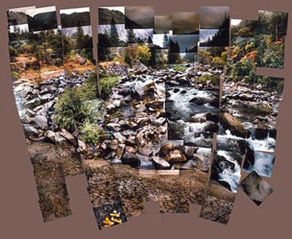

David Hockney

Pablo Picasso