By now you have your own interests within art. Here is the chance to go into depth. An opportunity to be free and without restriction! A chance to work as a real artist!

Unit 11

“I am the Artist”

Own choice Project

I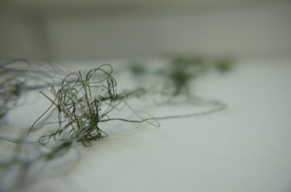

**Investigation Work Book = 40/60% you can choose**

**Culture and Context**

Analyse and compare, art from different cultures and times, carefully consider the function and significance.

**Technical Process**

Demonstrate the development

of effective skills, techniques

and processes when making

and analysing images and

artifacts.

**Investigation**

Demonstrate coherent and

focused investigative strategies into visual qualities, ideas and their contexts. Use a range of approaches towards their study, and make connections between them.

**Depth and Breath**

Demonstrate depth and

breadth through a mostly

successful development of ideas and explain connections

between the your work and that of artists.

**Presentation Criteria – (Considered on every page)**

**Vocabulary**

Demonstrate careful and accurate use of the specialist vocabulary of visual arts.

**Acknowledge Sources**

Use an appropriate range of sources and acknowledge them properly.

**Presentation**

Presents the work effectively and creatively and demonstrates some good critical observation and reflection.

**Integration**

Present work effectively and creatively, demonstrating good critical observation and reflection.

Make IWB pages that research the contextual background of your study. What culture are your ideas prominent within? Compare and contrast these ideas with other cultures and time periods. What artists were making artwork about a similar topic or media?

Create a mind map exploring your area of study. It must highlight what your key focus will be, what will be your influences (artists, objects, theory) and how many studio pieces you will aim to make.

Investigate artist’s techniques through analysis, explaining how meaning is portrayed, and demonstrating such techniques yourself. Reflect on this and talk about your own ideas.

Develop these ideas through experimentation in a wide variety of media. Use the media in a variety of different ways always reflecting and considering your theme.

Investigate deeper by using a relevant article. Choose your media and techniques according to this research. Use symbolism in your art.

Show your making process by photographing your steps, explain your decisions and be critical. Write a detailed reflection when you’re done.

**Studio Work = 40/60% you choose**

**Final Piece Criteria**

**Understanding**

Exhibit clear understanding

of the ideas and techniques that underpin artistic expression

**Relevance**

Consistently demonstrate the

production of personally relevant artworks that show exploration of ideas reflecting

cultural and historical

awareness and artistic qualities.

**Development**

Show thoughtful development

of ideas and strategies for

expression.

**Sensitivity**

Display sensitivity to materials

and their use. Review,

modify and refine your work as it progresses, resolving your ideas and media.

**Technique**

Display excellent technical

Competence.

**Confidence**

Demonstrate confidence and

inventiveness.

**Independence**

Shows an informed, reflective

judgment that challenges and

extends personal boundaries.

**Appropriate Resources**

**Things to Consider**

Have I put in appropriate time and energy?

Have I truly explored my ideas to create interesting, adventurous studio work (or have I just settled for the obvious)? Have I used any unusual or unexpected combinations of ideas or materials in my studio work?

How are the ideas in my studio work connected with my own life and cultural background? Have I created strong, powerful pieces of art work which *really mean something* to me?”

Are the ideas behind my studio work well suited to the techniques and media that I have chosen to use? What is the personal, cultural or visual meaning/purpose of my studio work?

How effectively have I designed the appearance of my studio work? Have I used visual language well? (line, composition, form, tone, colour, texture etc) Which visual or artistic problems have I encountered and have I solved them well?

Am I using my chosen media with high levels of skill? What visual effects do I want to create? How effective is the medium I have chosen at creating these effects? Would it be better to choose a different medium?”

Can I distinguish between my good and not-so-good art works, explaining how each piece has contributed to my improvement?

**Limitations**

Keep your work along the same theme and include your previously successful ideas. Otherwise, there are no limitations to this project. You can use any media, in any size, in any place.

**Studio Work Instruction**

At regular points throughout your investigation you should create your chosen amount of studio.

The work should relate directly to your IWB.

After each piece is completed, reflections and further exploration should continue in the IWB before the next one starts.

Keep in mind that this is where you create your best work so far and the majority of this will be submitted. So take time to have a professional finish!!

Andy Goldsworthy

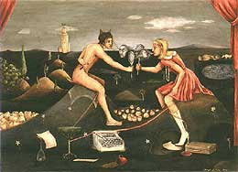

Seraphine Pick

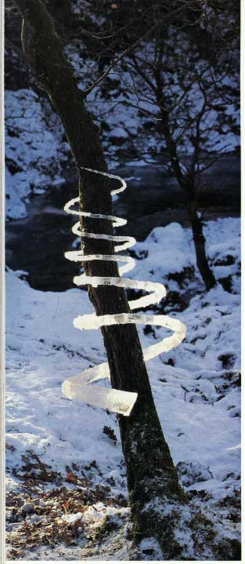

Peter James Smith

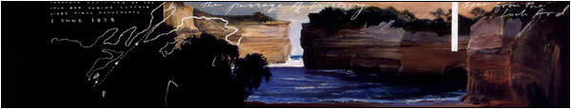

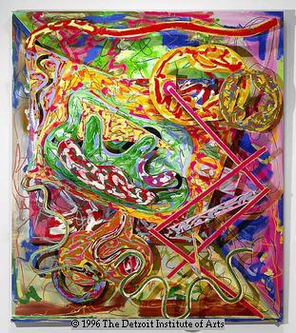

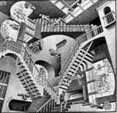

**Deadline = First lesson back**

**Minimum Pages = 10 + Final Piece/Pieces**

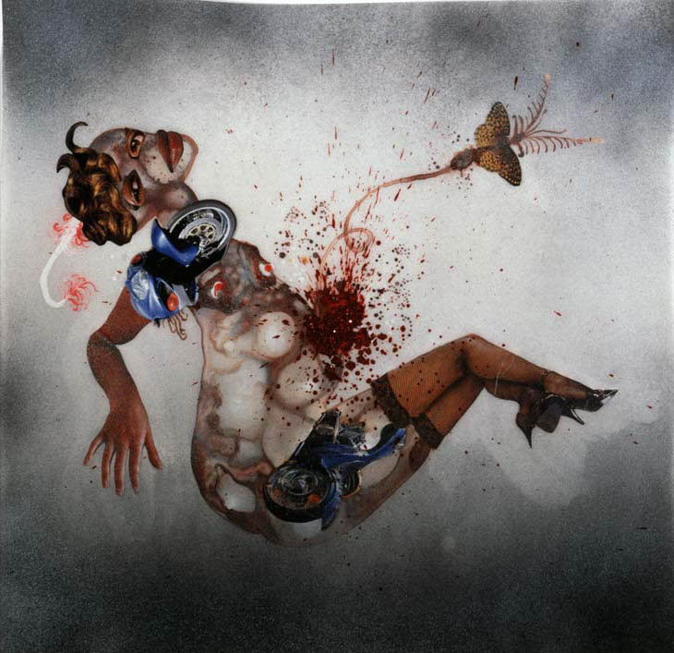

[www.art.sy.com](http://www.art.sy.com)

Go to see exhibitions!!!!

For what’s on see:

‘That’s Shanghai’ Magazine

[www.smartshanghai.com](http://www.smartshanghai.com)

<http://pearllamgallery.blog.com/>

http://www.tokyogoodidea.com/galleries

http://www.rockbundartmuseum.org/cn/cn_newsList.asp

<http://suisvisualarts.weebly.com/>

[www.art21.org/](http://www.art21.org/)

<http://www.artasiapacific.com/>

<http://www.moma.org/>

<http://www.nga.gov/collection/anA1.htm>

<http://www.artincontext.org>

The Tate Gallery/Tate Channel (artist interviews)

<http://www.artreview.com/>

<http://www.guardian.co.uk/artanddesign>

Look in books and Magazines..

Art Monthly (In our Library)

**http://artradarjournal.com/**

**http://www.oddee.com/item_96507.aspx**

Book - ***Installation Art.*** Nicolas de Oliveira.

Journals – **Art Journal** N81 A887

**Artforum** N1 A814

**Flash Art** N1 A1 F533

**Parachute: Contemporary Art Magazine** NX1 P37

**Parkett** NX3 P37

**Sculpture** NB1 S381

M C Escher

Frank Stella

Wangechi Mutu