Step 1: Creating the CUTOUT look
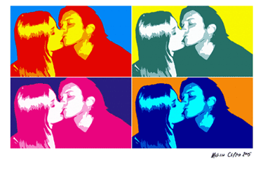
If you are a fan of Pop Art and the work of Andy Warhol, then this is the Adobe Photoshop tutorial for you.

Preparing the Photo
- Open up your photograph/soon-to-be-masterpiece in Photoshop and duplicate the background layer. Just click the layer called “Background” and drag it to this icon at the bottom of the layer window to duplicate the layer..
- Create a new layer (). Make this new layer white. Drag it below the “Photo” layer .You can delete the original layer called “Background”. Your layers window should look like the one in the picture below.
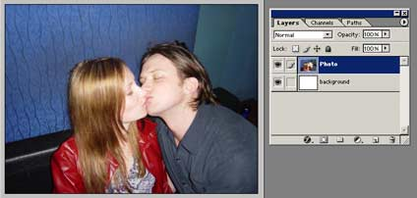
- Now working on the Photo layer we need to clear out all the unwanted parts of the photograph. In this case I want to isolate the kissing couple and delete the rest i.e the background walls and sofa. First select the background erase tool, erase a small patch to make sure the tool is on. Then use the lasso tool to select sections of the background, using Ctrl X to cut out section by section.
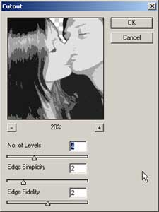
- Desaturate the photo (Ctrl + Shft + U) and Crop so that the photo has an interesting composition. 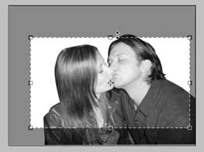
- Adjust the Brightness/Contrast… Image >> Adjustments >> Brightness/Contrast
- Adjust the sliders until your photo becomes quite dramatic. Now comes the fun part…

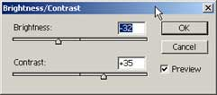
- Cutout Filter
Apply the Cutout Filter to the “photo” layer with the settings approximately as shown at right.
Filter >> Artistic >> Cutout…

- Cutout Filter AGAIN.
Now apply the cutout filter again, this time increasing the edge simplicity. The idea behind this is really to abstract and simplify the photo. Of course don’t just use the numbers shown below, trying experimenting!
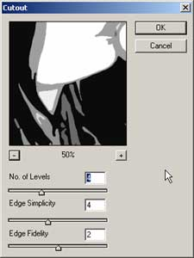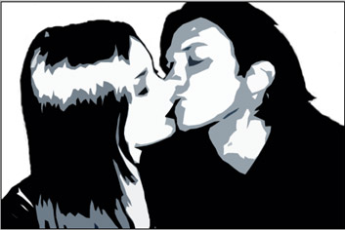
Adjust the levels again if you feel the urge. I like the look of 3 tone (white, black and grey)..
- Save your file in your folder.
- Save as a .jpg in the “to Print Folder” We will use this image to create stencils!
Now let’s organise the canvas and create an Andy Warhol inspired layout.

Step 2: Repeating the Image (Optional)*

*This option is an extension option. If you will not choose to repeat the image 4 times, skip ahead to Step 3: Adding Colour.

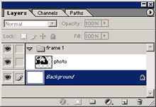
Preparing the Canvas. Open up a new canvas (Ctrl +N). The size is A4 (landscape) so 297x210mm.. Use 300 dpi for the best quality print.

Now go back to your original canvas. Click on your “photo” layer and drag and drop it onto you new “Warhol” canvas. Put the “photo” layer into a set. To create a new set, simply click this icon ( ) at the bottom of the layers window. Place the layer into a set by click dragging them onto the set. Rename the set appropriately e.g “frame 1″. Your layers window should now look like the image shown at right.
- Create a new layer and rename e.g “bg1″. Make sure it is in the “frame 1″ set and below the “photo” layer. See the following image.
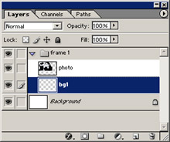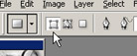
- Working on the “bg1″ layer take the Rectangle Tool …not to be confused with the marquee tool…this tool is grouped with the custom shape tool. Shft + U () and drag a rectangle to the size of the “photo” layer. Make sure the mode is set to Shape Layers before you draw the rectangle!!!! See image below. The image below shows you how your work area should look now. Don’t worry about the size of the “photo” and “bg1″ layers, we are about to adjust that.
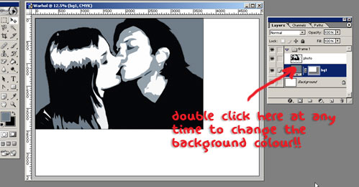
- Make sure your Rulers are on (Ctrl + R), and drag two guides to divide up the canvas into 4 sections. Take your time and get it exact. See below.
*TIP: Make sure SNAP TO GUIDES is on and use the rectangular marquee with the INFO WINDOW to measure distances.
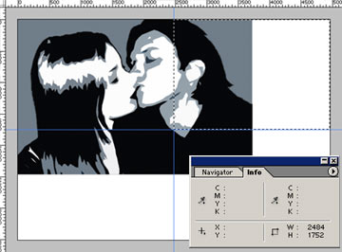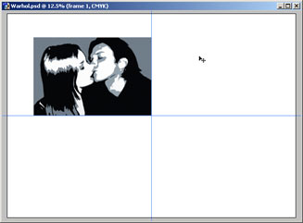
- Now click on your “frame 1” set in your layers window. We are going to transform the two layers of this set.
Edit >> Transform >> Scale
Hold down Shft as you scale down so that pic maintains it’s correct proportions. You want to achieve something like the picture below. See how the bottom-right corner rests in the centre of the canvas. Press Enter to complete the scaling.
- Right click on the “frame 1″ set and select Duplicate Layer Set…. Do this 2 more times so you have a total of 4 sets. Rename all your sets to “frame 2″, “frame 3″, and “frame 4″.
- Now move all the sets into the right positions. If you hold down Shft as you drag the sets, it constrains the movement to only vertical or horizontal…very handy!
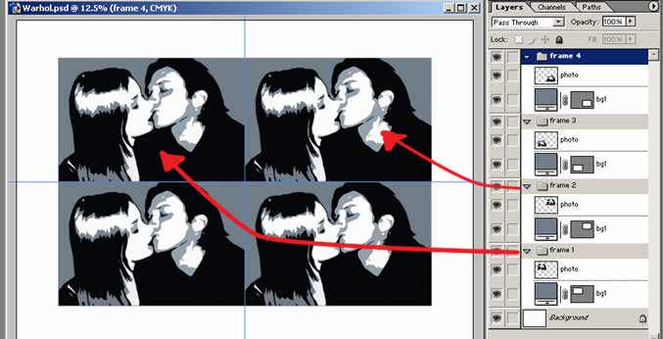
Right so now your work area should look like the image above. Almost there!
Actually now might be a good time to remind you to Save.
Use the move tool and the keyboard arrow keys to move the sets apart a little and get the composition just right.

STEP 3: Adding Colour
The second half of this tutorial should be relatively fast…provided you can decide on the right colour combinations!
Someone once asked Andy Warhol…
“What are the right colours? How do you know which are right?”
Andy Warhol’s reply…
“Well I don’t know, after you finish it you know what’s right.”

Adding the Color
Change the “bg1″ color for each set by double clicking on the Layer Thumbnail as shown below. Select a colour from the Color Picker window that pops up and then click OK.
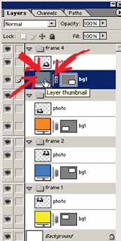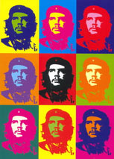
Not sure what color to use? Use the Andy Warhol picture below as a guide.
Now to add color to the people. There are two methods here so you can experiment around a little to see what you like best.

Method 1
Create a new layer in the “frame 1″ set and rename it “pc”. (That stands for people color, not very imaginative). Place this layer between the two existing layers. See below picture.
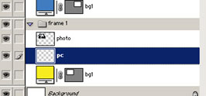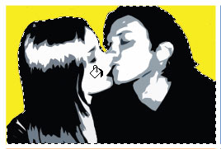
Click on your “photo” layer in your layer palette then
Select >> Load Selection
Look at the canvas and you will find the “photo” subject/s perfectly selected. Now still working on the “pc” layer, grab the paint bucket tool and fill the selection with you a vibrant color.

Now click on the “photo” layer and change the mode to Screen. See images below.
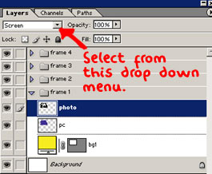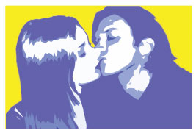
The result I achieved with method 1…

At this stage you can bump up the saturation
Image >> Adjustments >> Hue/Saturation…
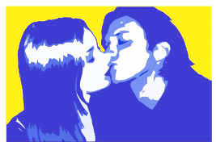
Try experimenting with Hue also, you may get some interesting results!

Method 2
Working on the “frame 2″ set now, complete method 1. However this time we are going to take it a little further.
Click on the “photo” layer and merge down.
Layer >> Merge Down
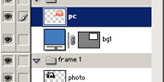
Create a new layer and rename it “pc 2″. Place this layer on top of “pc 1″ layer
Click on the “p1″ layer and LOAD SELECTION again. Fill the “pc 2″ layer with a vibrant color.
Now set the mode of the “pc 2″ layer to Multiply (depending on the colours other modes might produce good results). Your layers window should look like mine shown below.
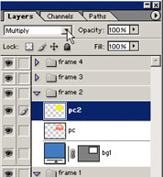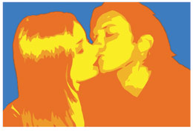
The result I achieved with method 2…

NOW EXPERIMENT! Try different color combinations. Try different modes. Try linking all the layers in one set together and merging THEN adjusting the Hue/Saturation…(Ctrl + U) on the layers.
Once you have completed all 4 sets and are happy with the result Save

